Practical Problem 01
1.a Data description
Attribute | Description
GEO Accession | GSE58135
Disease Studied | ER+ (Estrogen Receptor-positive) Breast Cancer
Organism | Homo sapiens (human)
Tissue / Sample Type | Primary ER+ breast tumor tissue vs. uninvolved breast tissue adjacent to the ER+ tumor
Sequencing Platform | Illumina HiSeq 2000 (GEO platform GPL11154)
Case Samples (n) | 42 ER+ primary tumors
Control Samples (n) | 30 uninvolved breast tissue samples adjacent to ER+ tumors
Experimental Design | Expression profiling by high throughput sequencing
1.b Data acquisition, filtering and Normalization
Data base : NCBI GEO datasets
Genes with CPM of grater or equal to 1 in at least 30 samples were retained and all other genes were filtered out.
Number of genes before filtering: 39376
Number of genes after filtering: 18118
Normalization:
Differential Analysis | Normalization Technique
DESeq2 | Median of ratios
EdgeR | TMM
Limma-VOOM | TMM and Log2 CPM
1.C Differential analysis
DGE analysis was performed using DESeq2, edgeR, and Limma-voom package in R. In each method, genes were called significant DEGs at adjusted p-value (FDR) < 0.05 and |log2FC| > 2.
Method | Up regulated | Down regulated | Total DEGs
DESeq2 | 625 | 720 | 1,345
edgeR | 596 | 868 | 1,464
Limma-voom | 353 | 822 | 1,175

Volcano plots
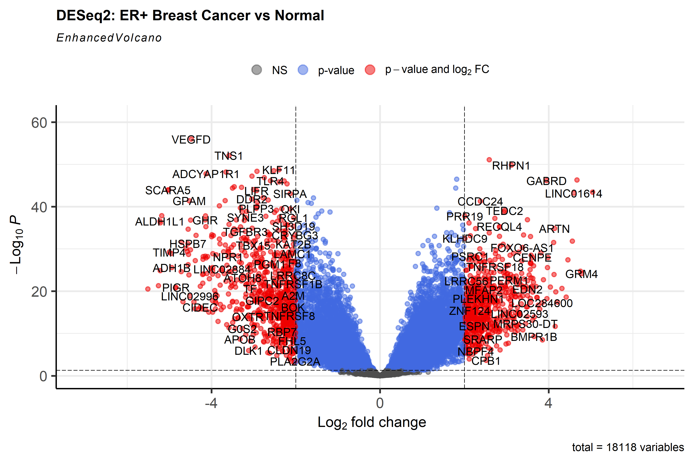
Figure 1. DESeq2 volcano plot.
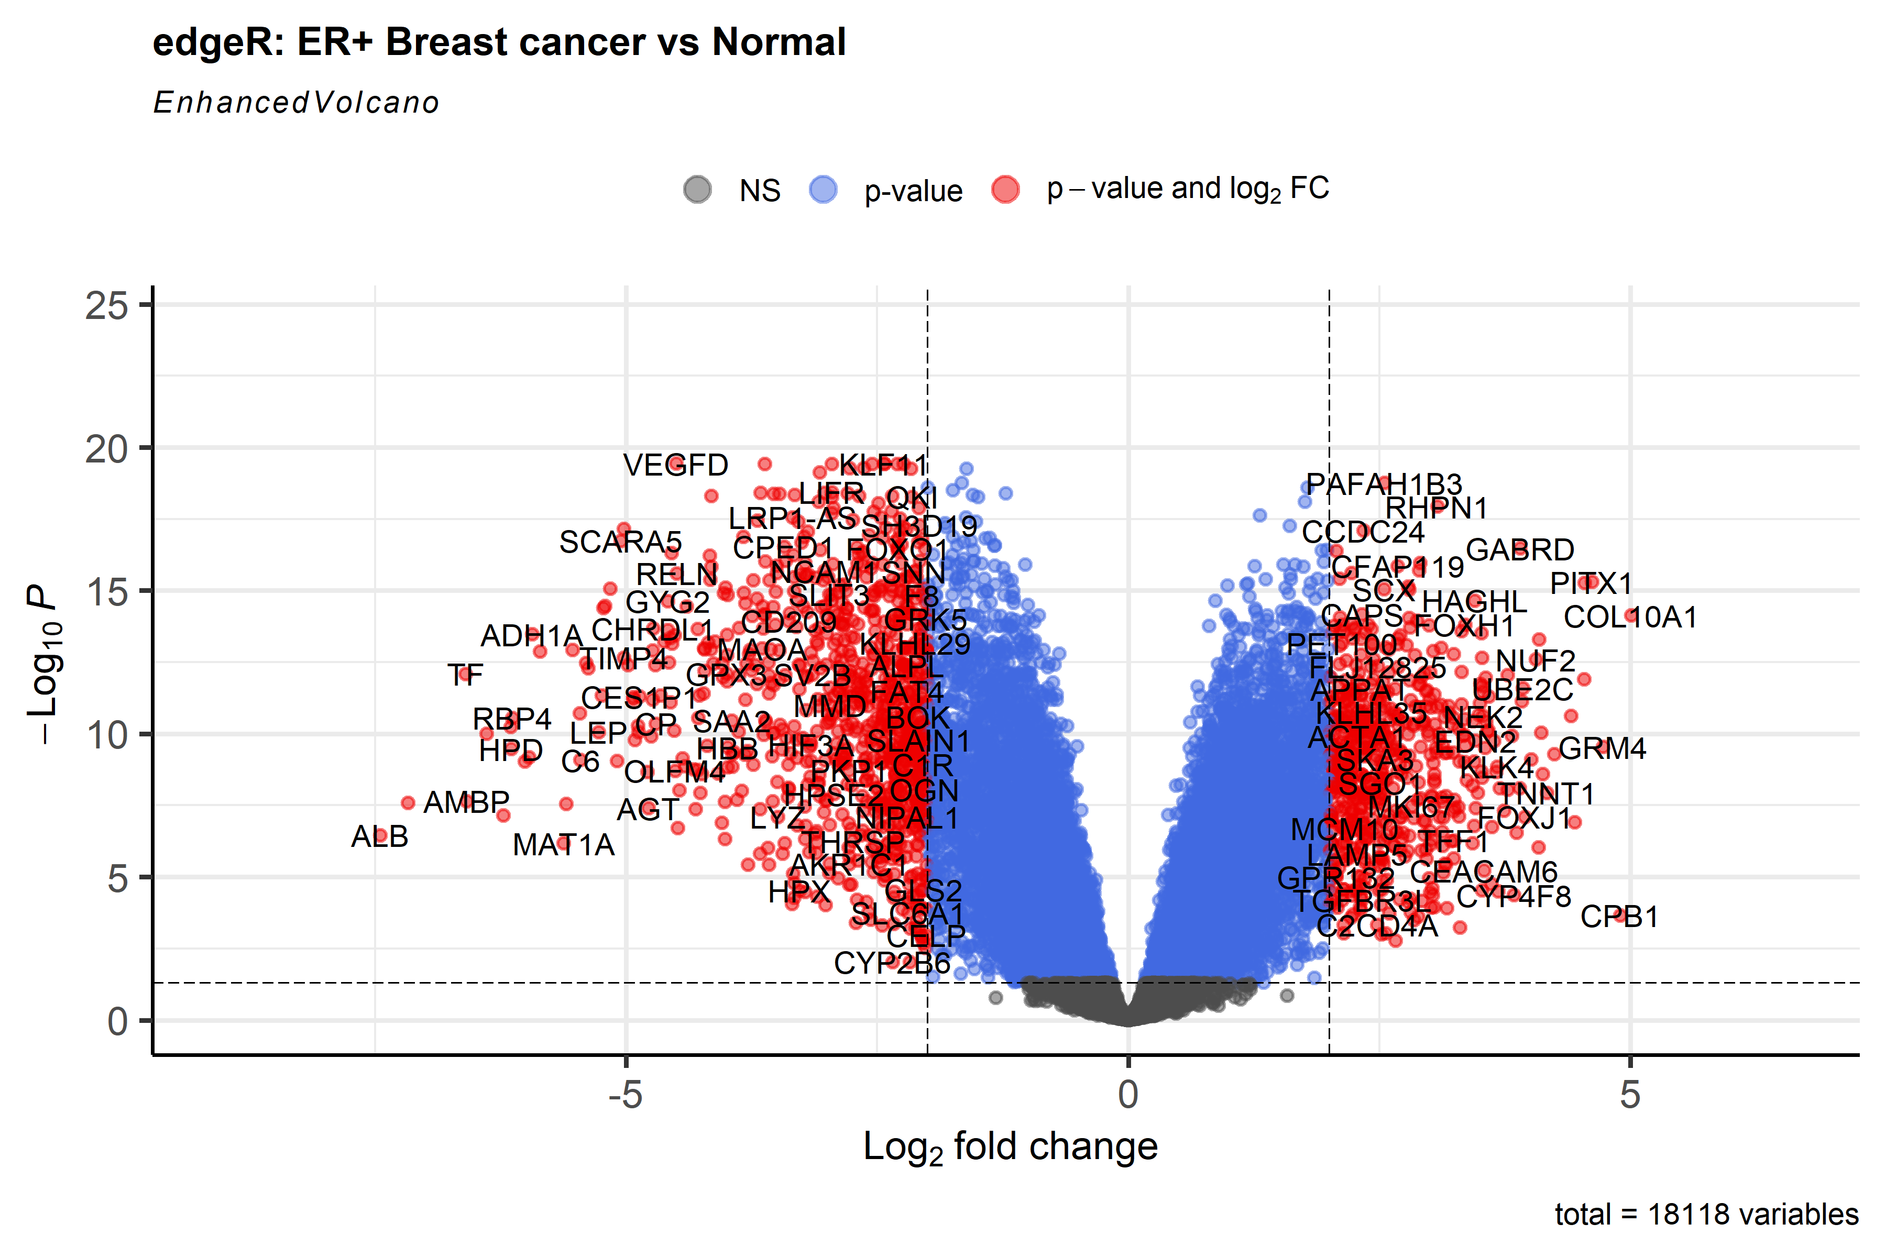
Figure 2. edgeR volcano plot.
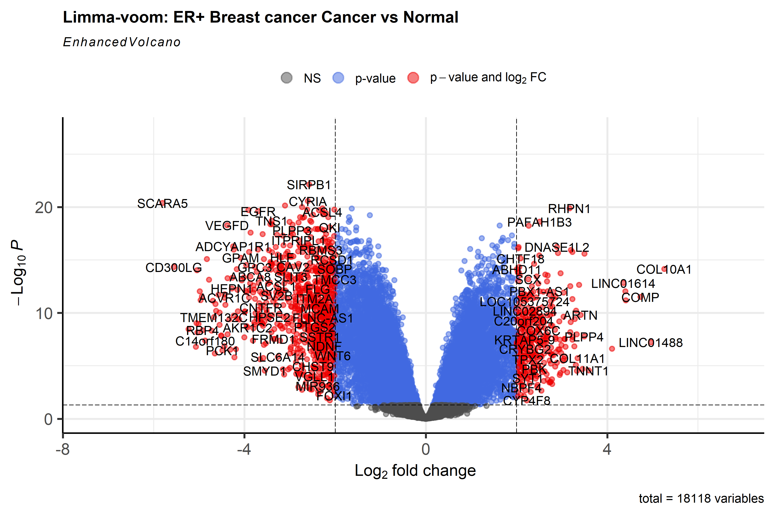
Figure 3. Limma-voom volcano plot.
Comparison
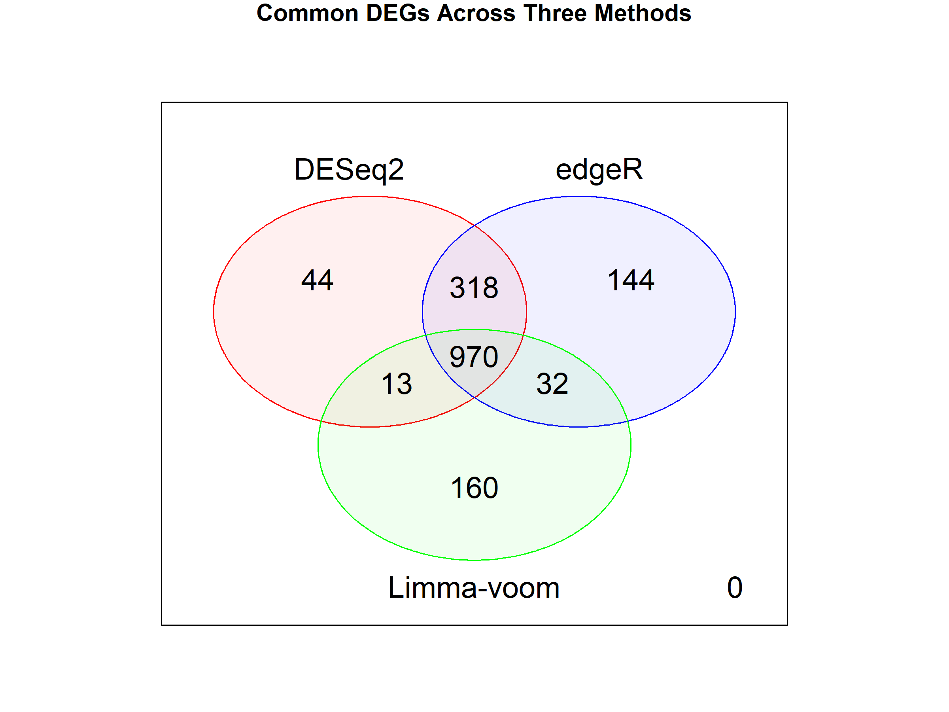
Figure 4. Venn-diagram of significant DEGs across DESeq2, edgeR, and Limma-voom.
1681 unique DEGs were identified across all three techniques. DESeq2 and edgeR produced similar totals while Limma-voom produced fewer DEGs. Limma produced most unique DEGs (160). DESeq2 produced least (44). 970 DEGs out of 1681 were common across all three techniques.
1.d Top 10 significant DEGs and therapeutic potential
The 970 DEGs common to all three methods were used to build a PPI network (NetworkAnalyst). Genes were ranked by network degree measure to obtain the ten most connected hub genes. Each gene was queried against DSigDB through enrichR.
Rank | Gene | Degree | Top DSigDB drug
1 | EGFR | 130 | trifluridine (MCF7 DOWN)
2 | H3C4 | 121 | etoposide (MCF7 DOWN)
3 | GNAI1 | 114 | protoporphyrin IX (CTD 00001323)
4 | KAT2B | 80 | ciclopirox (MCF7 DOWN)
5 | PLK1 | 78 | 5109870 (MCF7 DOWN)
6 | CDC20 | 77 | hematoxylin (BOSS)
7 | BUB1B | 70 | Bisphenol A (CTD 00000312)
8 | H2AC18 | 69 | Fulvestrant (CTD 00002740)
9 | GNG2 | 64 | Tyrphostin AG 1478 (TTD 00011607)
10 | KDR | 63 | Vatalanib succinate (TTD 00011775)

Practical Problem 02
2.a Data description
Two datasets from the same GEO series (GSE58135) were used, one per breast cancer subtype, each with its own matched normal samples.
Attribute | Dataset 1: ER+ | Dataset 2: Triple-Negative (TN)
GEO Accession | GSE58135 | GSE58135
Disease Studied | ER+ Breast Cancer | Triple-Negative Breast Cancer
Organism | Homo sapiens | Homo sapiens
Tissue / Sample Type | Primary ER+ tumor vs. adjacent normal | Primary TN tumor vs. adjacent normal
Sequencing Platform | Illumina HiSeq 2000 (GPL11154) | Illumina HiSeq 2000 (GPL11154)
Case Samples (n) | 42 | 42
Control Samples (n) | 30 | 21
Experimental Design | Expression profiling by high throughput sequencing | Expression profiling by high throughput sequencing
2.b Data acquisition, filtering and Normalization
Data base : NCBI GEO datasets
Genes with CPM of grater or equal to 1 in at least 21 samples were retained and all other genes were filtered out.
Number of genes before filtering: 39376
Number of genes after filtering: 18846
Normalization:
Differential Analysis | Normalization Technique
DESeq2 | Median of ratios
EdgeR | TMM
Limma-VOOM | TMM and Log2 CPM

2.C Differential analysis (each dataset)
Dataset 1: ER+ Breast Cancer
Method | Up regulated | Down regulated | Total DEGs
DESeq2 | 625 | 720 | 1,345
edgeR | 596 | 868 | 1,464
Limma-voom | 353 | 822 | 1,175
Dataset 2: Triple-Negative Breast Cancer (Criteria: FDR < 0.05, |log2FC| > 2)
Method | Total DEGs
DESeq2 | 1,924
edgeR | 1,951
Limma-voom | 1,786
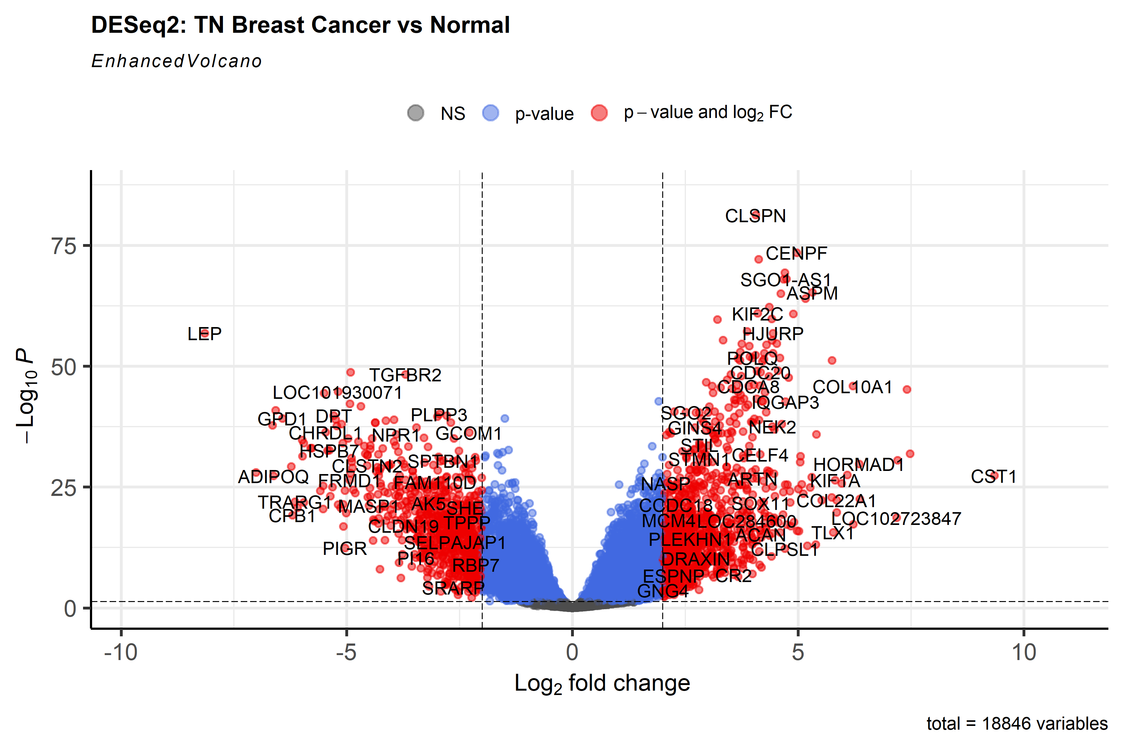
Figure 5. DESeq2 volcano plot, TN breast cancer vs. normal.
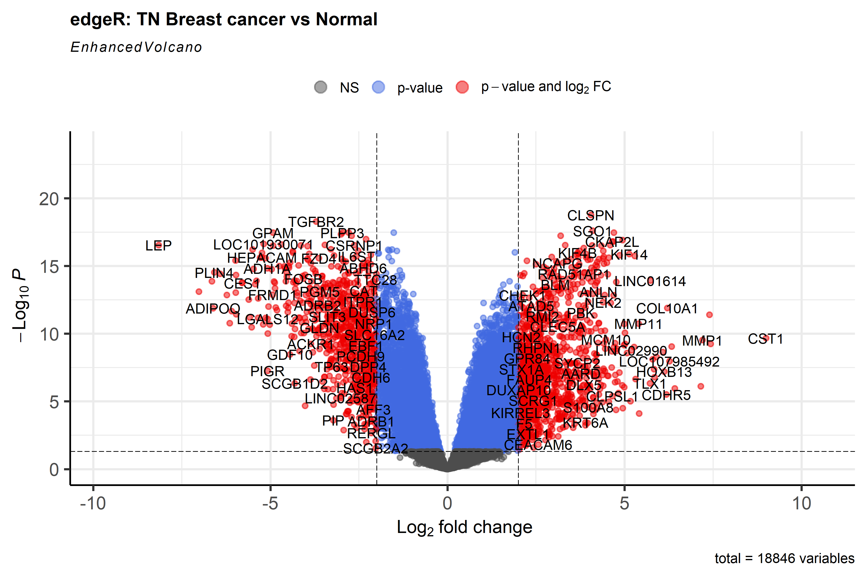
Figure 6. edgeR volcano plot, TN breast cancer vs. normal.
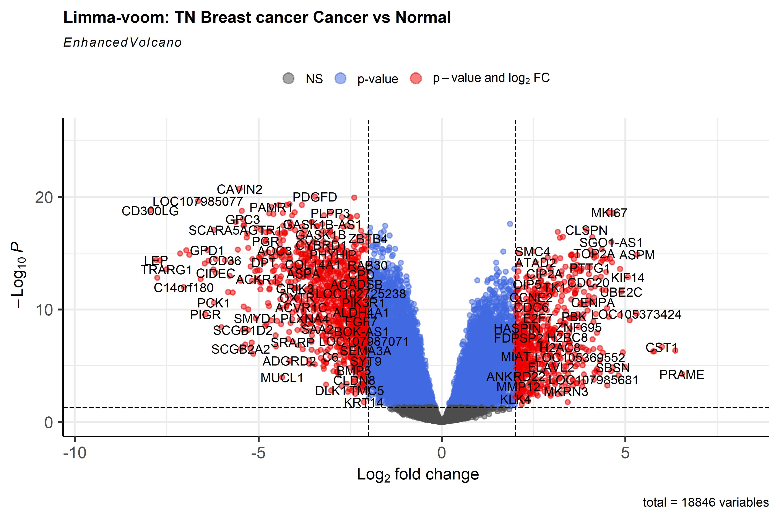
Figure 7. Limma-voom volcano plot, TN breast cancer vs. normal.
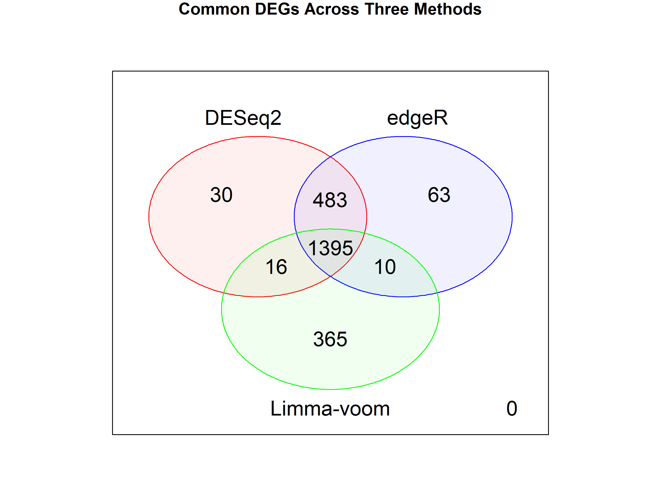
Figure 8. Venn-diagram of significant DEGs across DESeq2, edgeR, and Limma-voom, TN dataset.
2362 unique DEGs were identified across all three techniques. Limma-voom produced most unique DEGs (365). DESeq2 produced least (30). 1395 DEGs out of 2362 were common across all three techniques.
Comparison across datasets
The TN dataset produced more DEGs than the ER+ dataset at every method. In both cases Limma-voom produced the most unique DEGs. Intersecting the two common DEG sets (970 ER+ genes and 1,395 TN genes) gave 527 common DEGs for both subtypes of breast cancer.

2.d Top 10 common DEGs and therapeutic potential
The 527 common DEGs for both datasets were used to build a PPI network (NetworkAnalyst). Genes were ranked by degree to obtain the ten most connected hub genes. Each gene was queried against DSigDB through enrichR.
Rank | Gene | Degree | Top DSigDB drug/compound
1 | H3C4 | 121 | trifluridine (MCF7 DOWN)
2 | GNAI1 | 114 | etoposide (MCF7 DOWN)
3 | PLK1 | 78 | ciclopirox (MCF7 DOWN)
4 | CDC20 | 77 | 5109870 (MCF7 DOWN)
5 | BUB1B | 70 | resveratrol (MCF7 DOWN)
6 | H2AC18 | 69 | thalidomide (CTD 00006858)
7 | GNG2 | 64 | dmnq (CTD 00002569)
8 | KDR | 63 | 362-05-0 (CTD 00000041)
9 | UBE2C | 61 | methotrexate (MCF7 DOWN)
10 | FOXO1 | 57 | caffeic acid (CTD 00001850)

Practical Problem 03
3.a Data description
Attribute | Description
Accession | PRJNA871997
Disease Studied | Type 2 Diabetes (T2D)
Organism (Host) | Homo sapiens (human)
Sample Type | Stool / gut microbiome
Sequencing Platform | Illumina MiSeq, 16S rRNA gene (V3-V4) amplicon sequencing
Case Samples (n) | 10 T2D subjects
Control Samples (n) | 13 healthy subjects
Experimental Design | Case-control comparison of gut bacterial community composition
Objective | To characterize gut microbiota differences between T2D patients and healthy subjects
3.b Data acquisition, filtering and Normalization
Filtered using a prevalence threshold: taxa retained if present in at least 5% of samples.
Normalization:
Analysis | Normalization Technique
Alpha / Beta diversity, Taxonomy | Rarefaction to even sequencing depth
metagenomeSeq | Cumulative Sum Scaling (CSS)
DESeq2 | Median of ratios
edgeR | Library-size normalization

3.c Alpha and Beta diversity
Alpha diversity
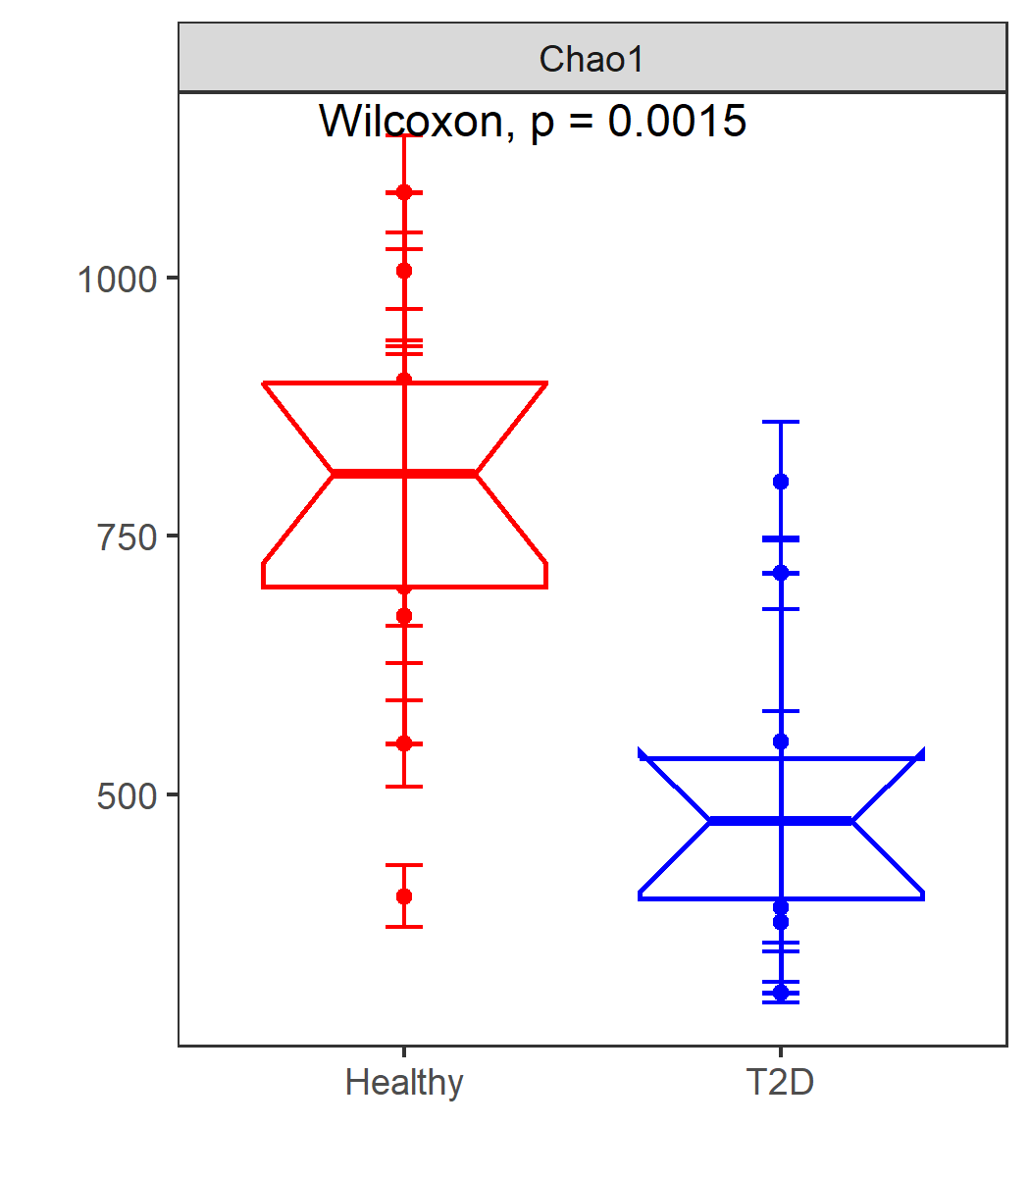
Figure 1. Chao1 alpha diversity, Healthy vs. T2D.
Chao1 richness was significantly higher in Healthy subjects than in T2D subjects (Wilcoxon, p = 0.0015), indicating reduced gut bacterial richness in T2D.
Beta diversity
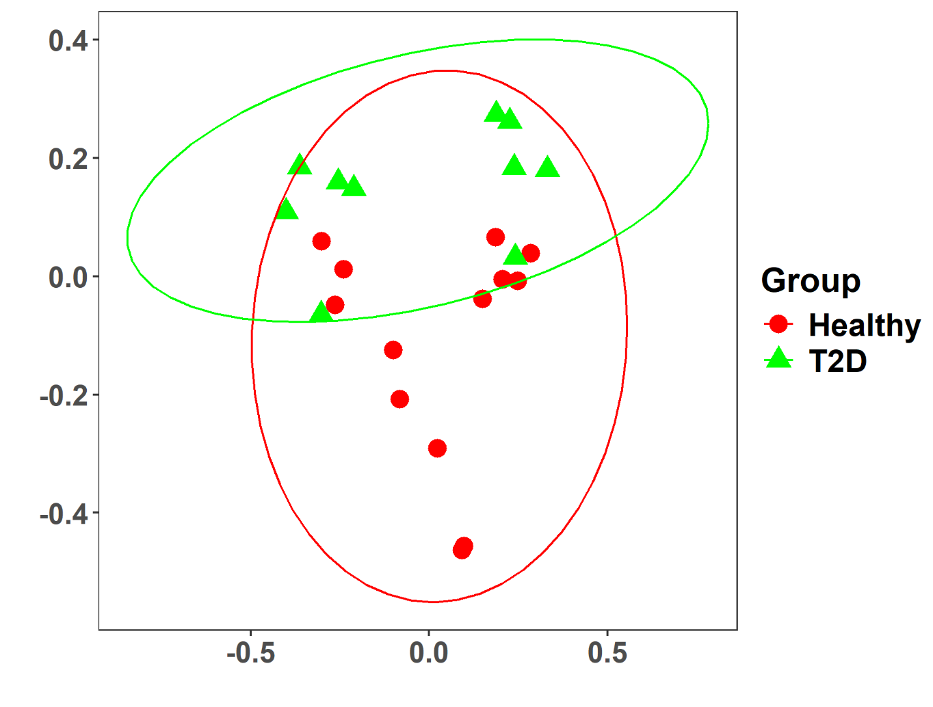
Figure 2. Bray-Curtis PCoA, Healthy vs. T2D.
PCoA plot showed separation between Healthy and T2D samples. PERMANOVA test also confirmed it (p-value = 0.047).
3.d Taxonomy analysis
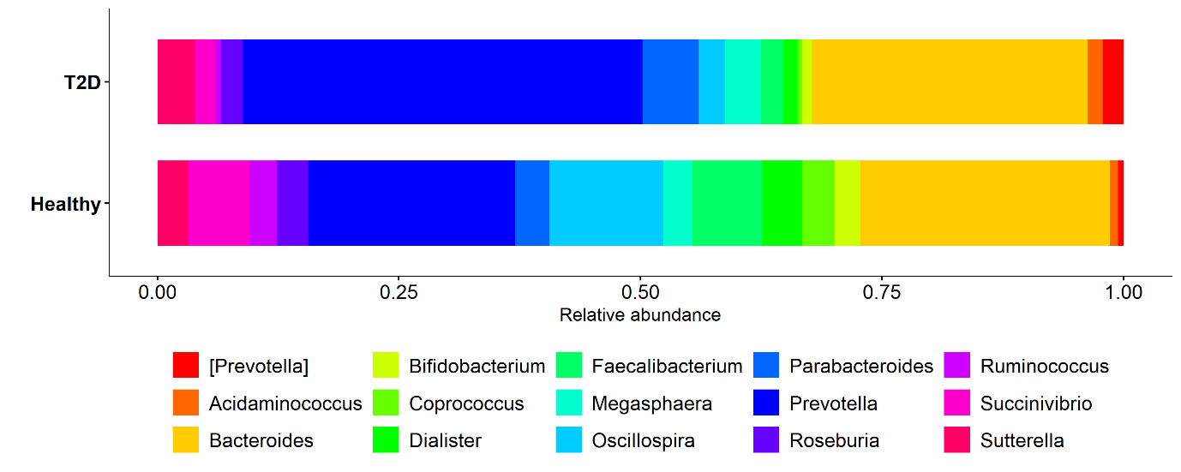
Figure 3. Top 15 genera by relative abundance, Healthy vs. T2D.
Prevotella was the dominant genus in both groups but occupied larger share of the community in T2D than in Healthy samples.
3.e Differential abundance analysis
Taxa were called significantly differentially abundant at adjusted p-value (FDR) < 0.05.
Method | Significant Taxa
metagenomeSeq | 2
DESeq2 | 117
edgeR | 140
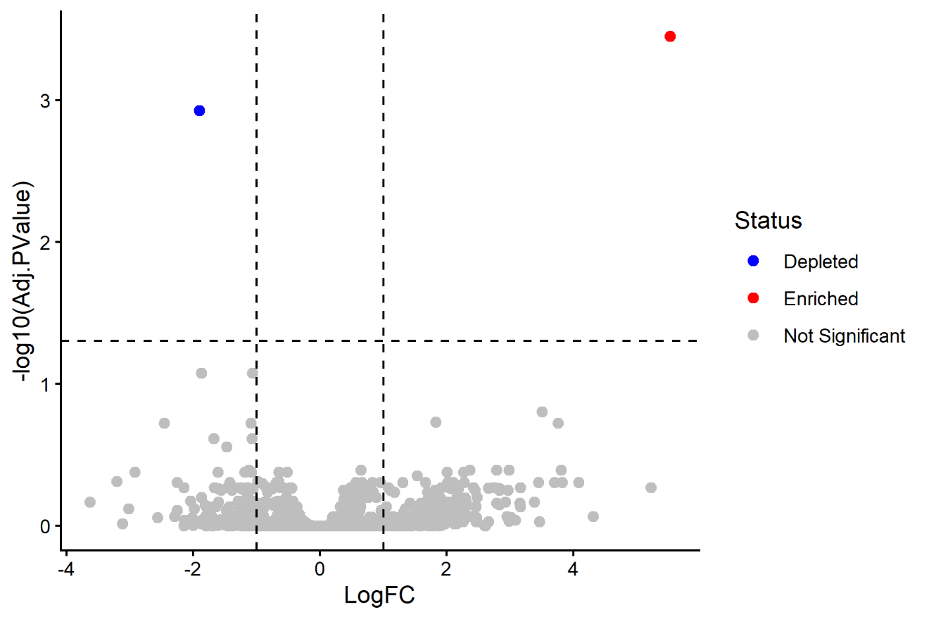
Figure 4. metagenomeSeq volcano plot.
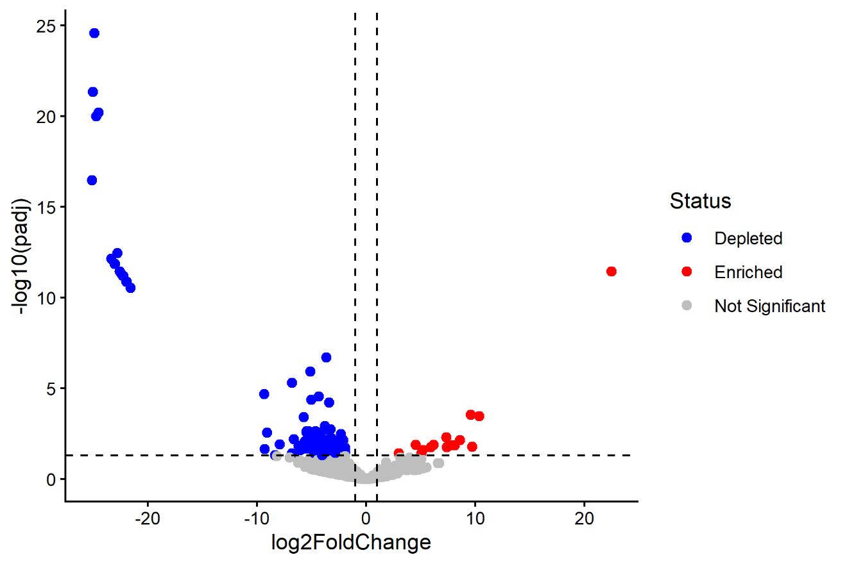
Figure 5. DESeq2 volcano plot.
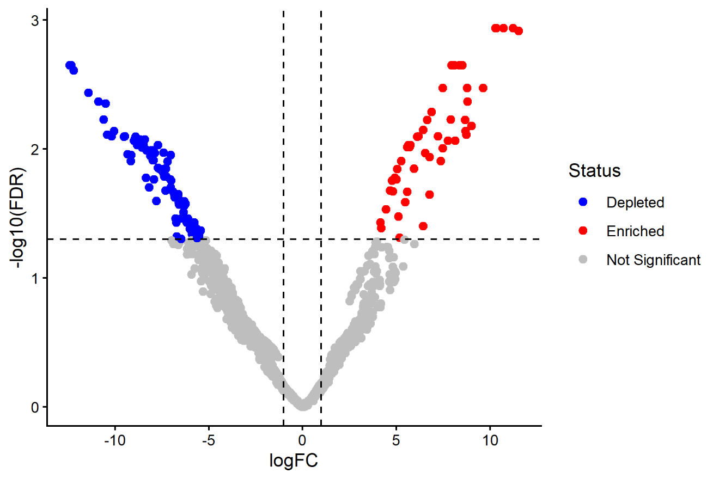
Figure 6. edgeR volcano plot.

Practical Problem 04
4.a Data description
Attribute | Dataset 1 | Dataset 2
Accession | PRJNA871997 | PRJNA820272
Disease Studied | Type 2 Diabetes (T2D) | Type 2 Diabetes (T2D)
Organism (Host) | Homo sapiens | Homo sapiens
Sample Type | Stool / gut microbiome | Stool / gut microbiome
Sequencing Platform | Illumina MiSeq, 16S rRNA (V3-V4) | 16S rRNA gene amplicon sequencing
Experimental Design | Case-control: T2D vs. Healthy | Case-control: T2D vs. Healthy
Objective | Characterize gut microbiota differences in T2D vs. healthy subjects | Characterize gut microbiota differences associated with T2D-linked dysbiosis
4.b Data acquisition, filtering and Normalization
Both datasets were filtered independently using the same prevalence threshold as Problem 3 (taxa present in at least 5% of samples).
The same normalization techniques used in Problem 3 (Section 3.b) were applied independently to each dataset.
4.c Alpha and Beta diversity (each dataset)
Alpha diversity
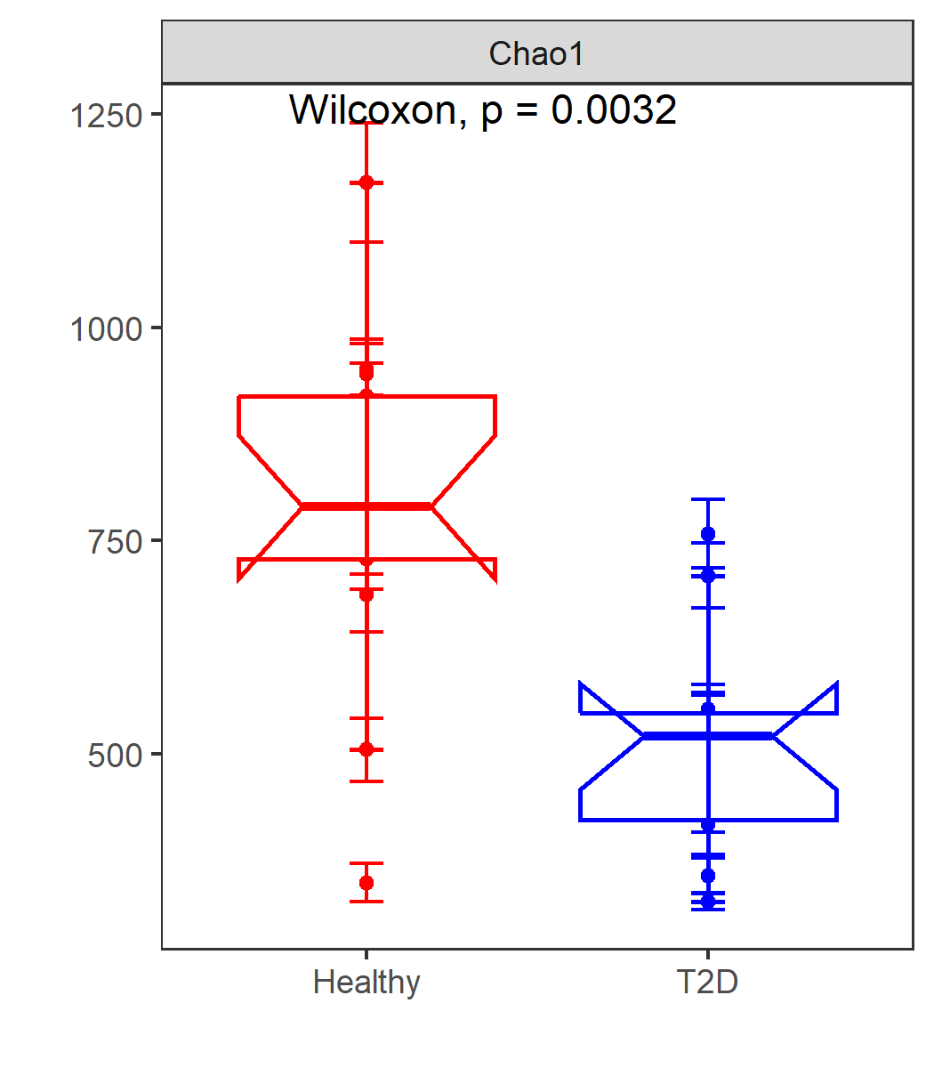
Figure 7. Chao1 alpha diversity, Dataset 1 (Healthy vs. T2D).
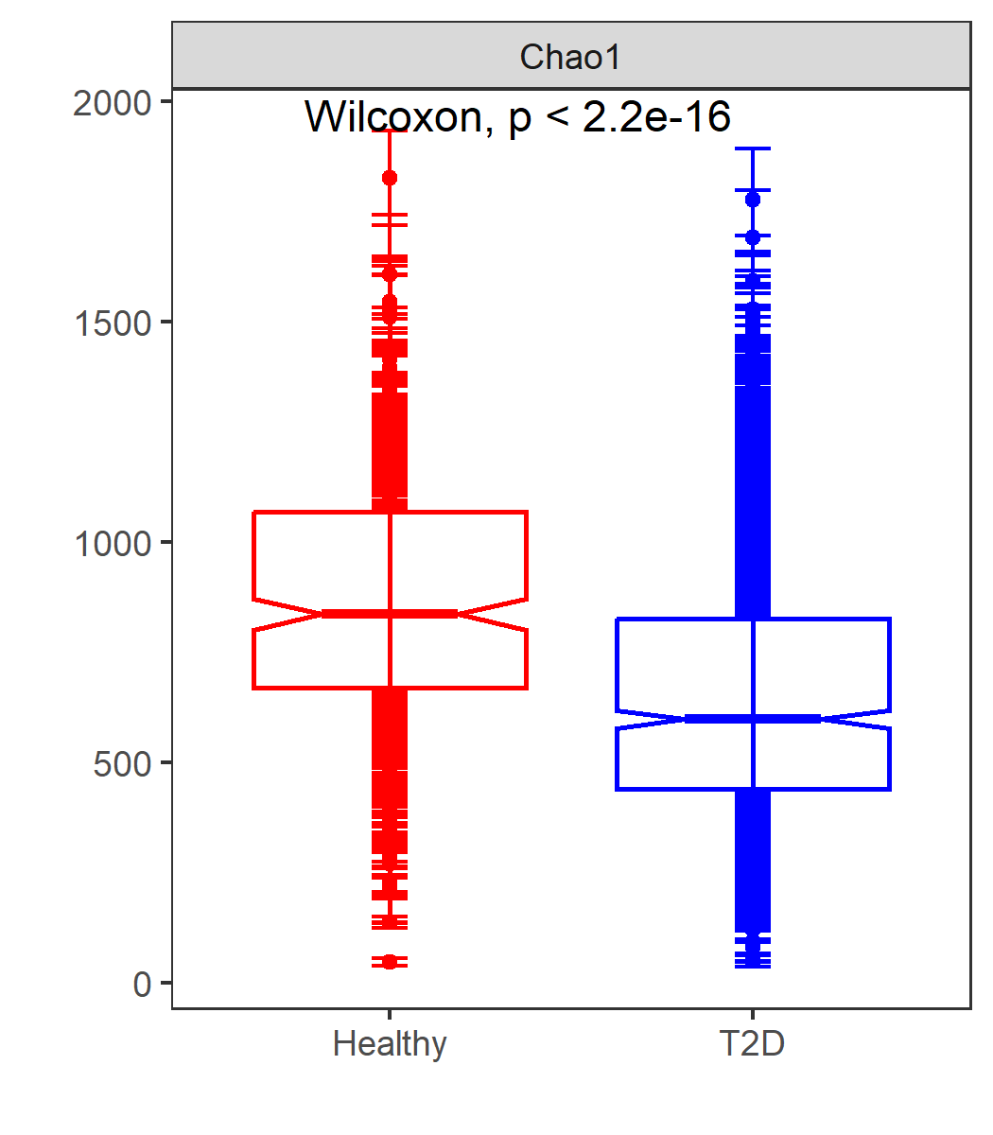
Figure 8. Chao1 alpha diversity, Dataset 2 (Healthy vs. T2D).
Both datasets showed significantly higher richness in Healthy subjects than in T2D subjects (Dataset 1: Wilcoxon p = 0.0032; Dataset 2: Wilcoxon p < 2.2e-16).
Beta diversity

Figure 9. Bray-Curtis PCoA, Dataset 1.
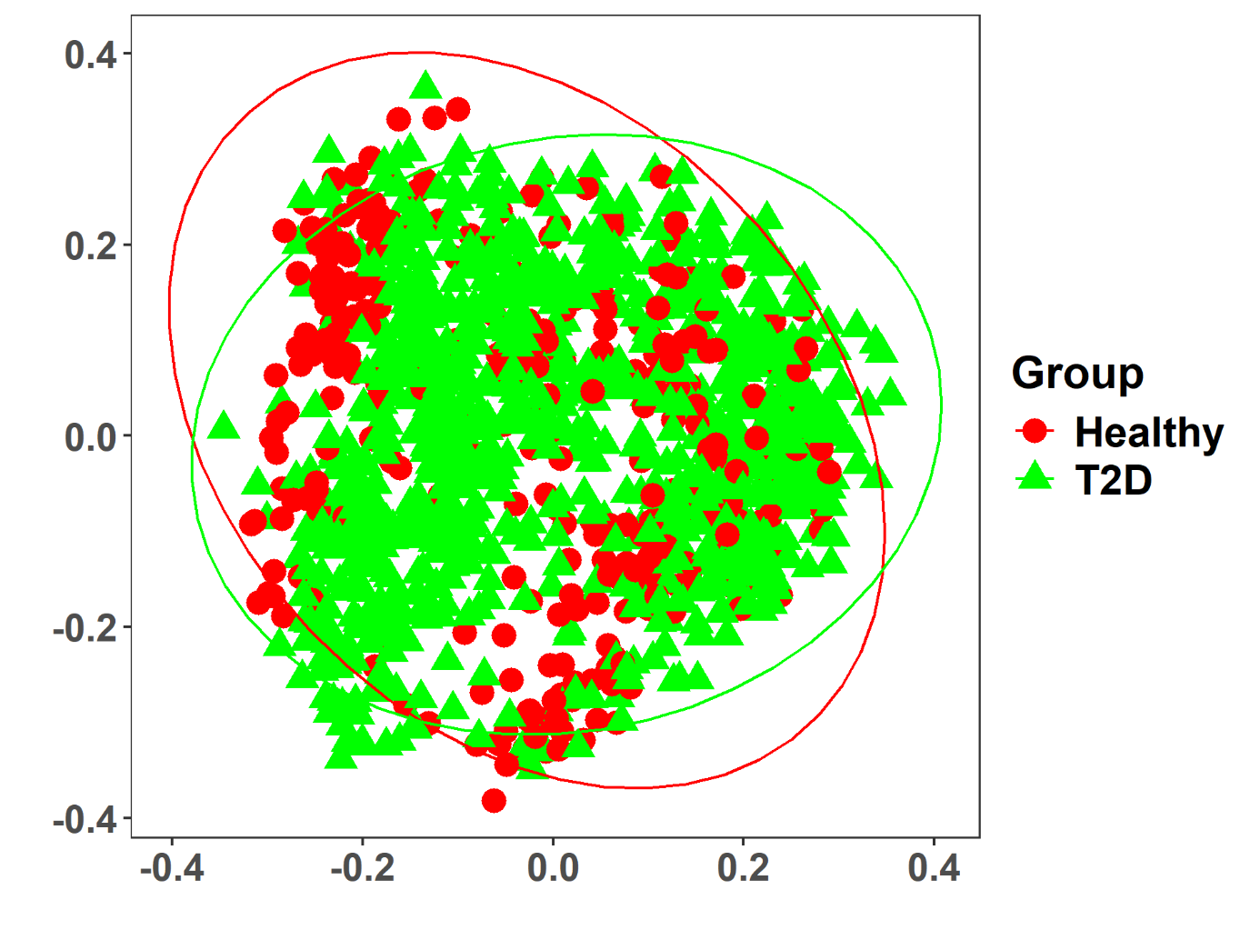
Figure 10. Bray-Curtis PCoA, Dataset 2.
Both datasets showed partial separation between Healthy and T2D samples.
4.d Taxonomic composition
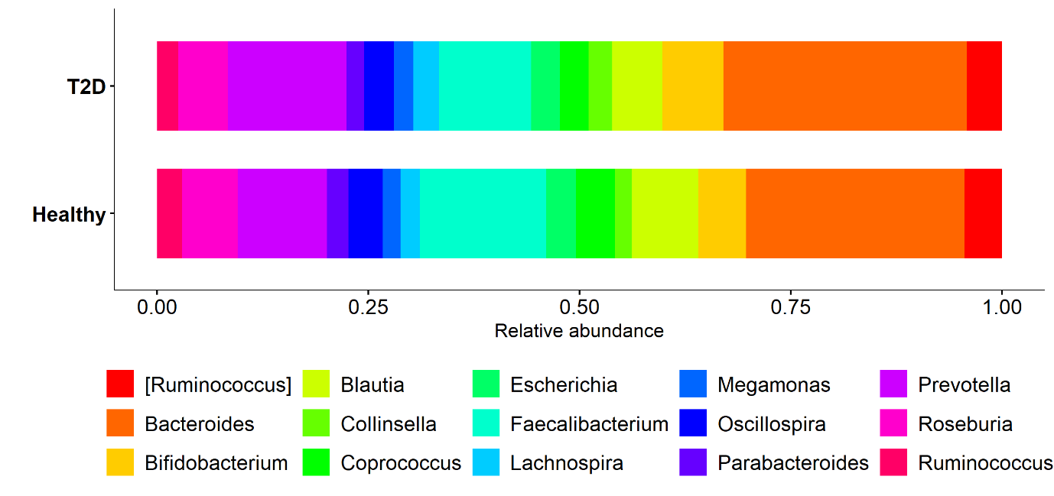
Figure 11. Top 15 genera by relative abundance, Dataset 2.
Dataset 1 was dominated by Prevotella and Bacteroides (Figure 3). Dataset 2 showed a broader representation of Firmicutes-associated genera, including Blautia, Coprococcus, Lachnospira, and Roseburia, alongside Bacteroides and Prevotella, indicating a more even genus-level composition than Dataset 1.

4.e Differential abundance analysis (each dataset)
Significance criterion: adjusted p-value (FDR) < 0.05, applied independently to each dataset.
Dataset 1
Same as Problem 3, Section 3.e: metagenomeSeq = 2, DESeq2 = 117, edgeR = 144 significant taxa (Figures 4-6).
Dataset 2
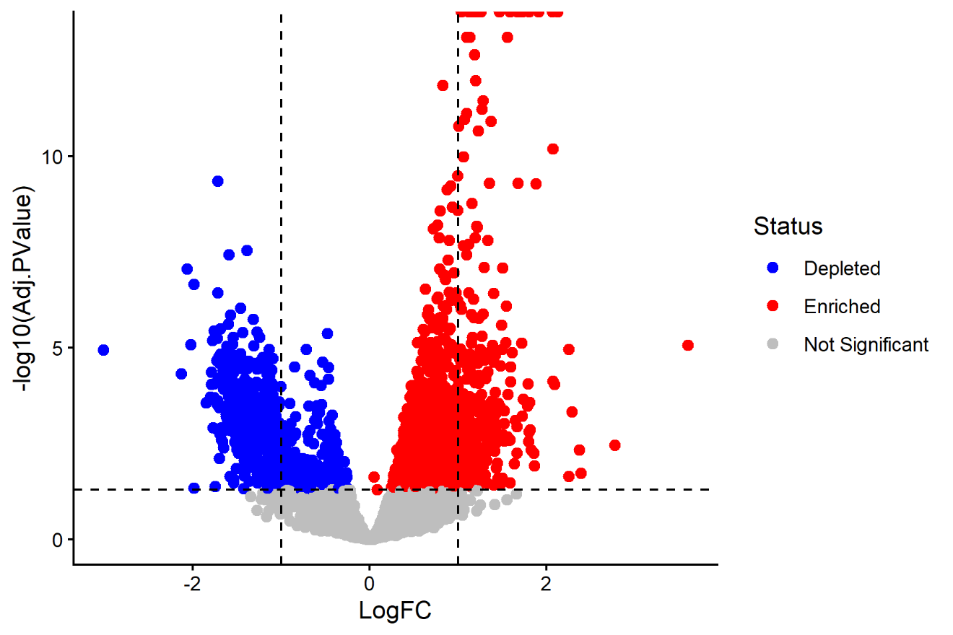
Figure 12. metagenomeSeq volcano plot, Dataset 2.
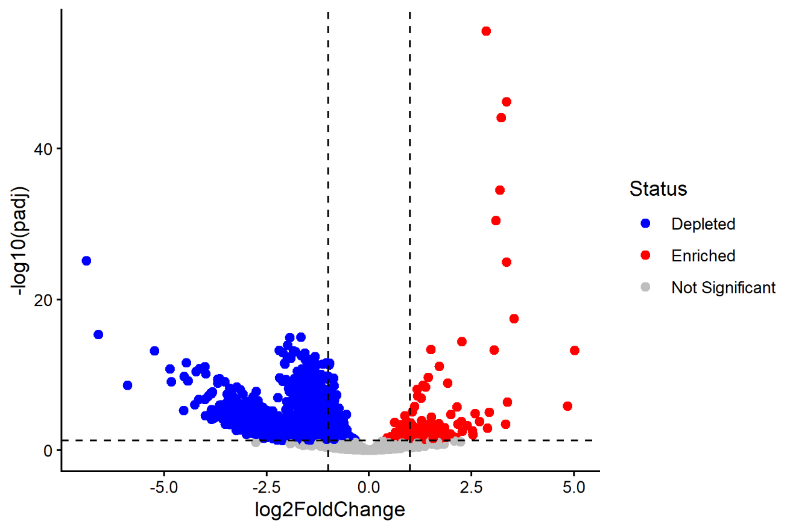
Figure 13. DESeq2 volcano plot, Dataset 2.
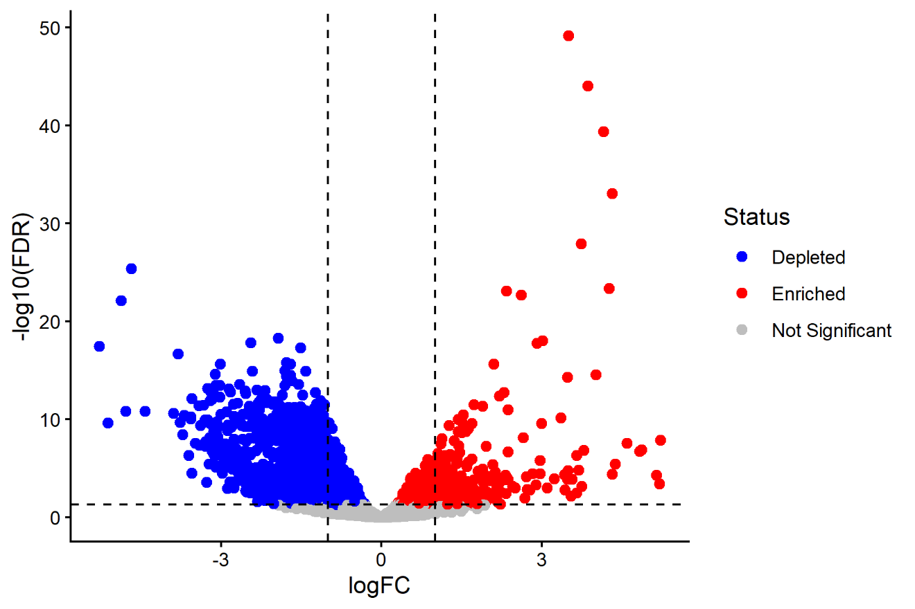
Figure 14. edgeR volcano plot, Dataset 2.
4.f Comparison across datasets
Method | Common Genera
DESeq2 | 80
edgeR | 80
metagenomeSeq | 80

